**Phrase #1**

________ ________

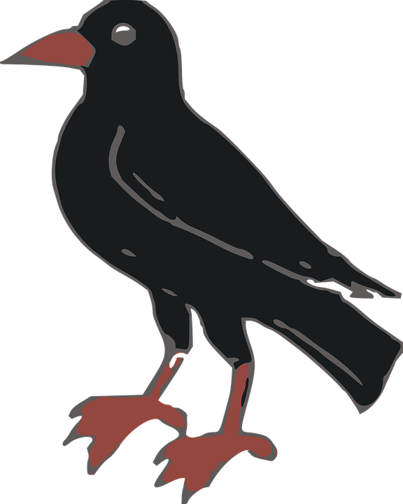

________ ________ ________ ________ ________ ________

     

________ ________ ________ ________

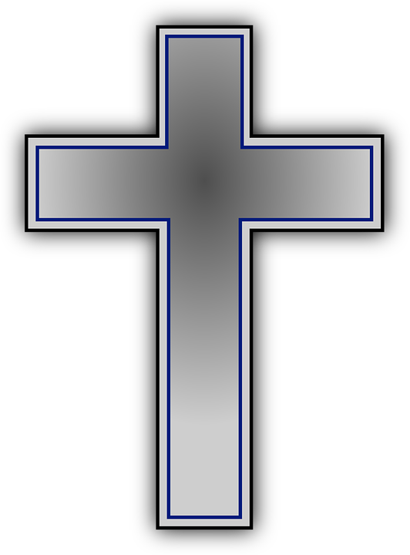  

________ ________

 

**Decode The Sermon**

You will need your decoder till the end of October. Every Sunday, their will be symbols that decode each word. However, the FIRST symbol is missing!!! You must listen for the missing symbol. When you get that symbol turn the letter A to match that symbol. Then start to decode your word. Don’t worry, the Pastor will always make sure you decoded the word correctly! Have fun and good luck!